H.T No
Regulations:
A15

Sreenidhi Institute of Science and Technology
(An Autonomous Institution)
Code No: 5B730 Date: 06-Oct-2020 (AN)

B.Tech IV-Year I-Semester External Examination, October - 2020 (Supplementary)
Finite Element Method (ME)

Time: 2 Hours Max.Marks:75

Note: a) No additional answer sheets will be provided.
b) All sub-parts of a question must be answered at one place only, otherwise it will not be valued.
c) Missing data can be assumed suitably.

ANSWER ANY FIVE QUESTIONS. EACH QUESTION CARRIES 15 MARKS.

1. | a) | Derive the element stiffness matrix for a 1-D bar element. State the properties of stiffness matrix. | [8M]
 | b) | For a stepped bar shown in figure.1 using elimination method of handling boundary conditions. Determine the following.  i) Nodal displacements ii) Stress in each element. Take E= 200GPa.  150mm² 240mm²  20kN  20Kn  10kN  75mm 75mm 60mm  Figure.1 | [7M]
2. | a) | What is a beam? Derive the hermite shape functions for beam element. | [8M]
 | b) | Find the nodal displacement, stress and reactions of truss element shown in figure.2. Take E=200GPa Area=200mm².  12kN  300mm  - - - -- - - - - - - - - - - - - - -  500mm 400mm  Figure.2 | [7M]
3. | a) | Define Iso-parametric, Super-parametric and Sub-parametric elements. | [8M]
 | b) | An axisymmetric ring element is shown in figure.3. Derive the strain displacement Matrix. Take E=2x10⁵N/mm².  2  50mm  . 1 3  100mm 50mm  Figure. 3. | [7M]
4. |  | An isoparametric element is shown in figure. 4(a), and a corresponding isoparametric distorted element is shown in figure. 4(b).Discuss the transformation that relates partial derivatives in the original x, y coordinates to the generalized ξ, η coordinates.  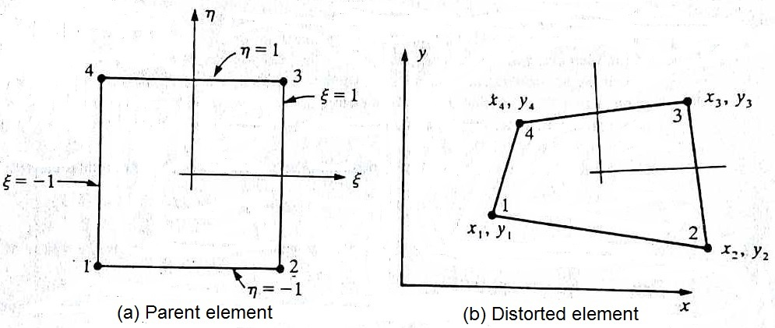  Figure. 4 | [15M]
5. | a) | Derive the element conductivity matrix for solving 1-D heat conduction problems. | [8M]
 | b) | A composite slab consists of 3 materials of different conductivities  i.e. 22 W/m K, 32 W/m K, 52 W/m K of thickness 0.31m, 0.14m and  0.14m respectively. The outer surface temperature is 22 ºC and the  inner surface is exposed to the convective heat transfer coefficient  of 28 W/m² K, at 800 ºC. Determine the temperature distribution  within the wall. | [7M]
6. |  | Determine the eigen values of the stepped bar shown in figure.5.  Take E=200GPa, weight density 7850 kg/m³.  A₁= 1200mm² A₂= 900mm²  x  300mm 400mm  Figure. 5. | [15M]
7. | a) | Discuss the Engineering applications of FEM. | [8M]
 | b) | Differentiate between local and global coordinates? Give examples. | [7M]
8. | a) | What is a higher order element? List some advantages of using 3-D elements in structural mechanics. | [8M]
 | b) | Name a few boundary conditions involved in any heat transfer analysis. | [7M]

-- 00 -- 00 –

